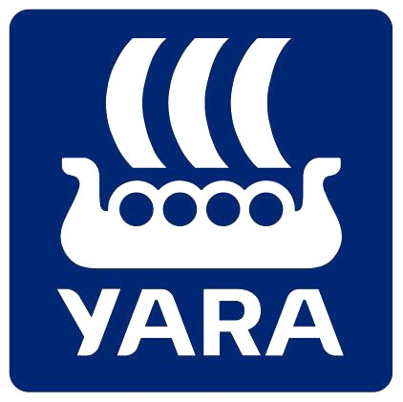

BGS GRASSLAND FARMER OF THE YEAR 2019
COMPETITION ENTRY FORM
LOCAL SOCIETY ENTRANTS – Complete the section below (A & B)

Candidate Details
First Name: | Click or tap here to enter text.
Surname:
Local Grassland Society:
Address:
Postcode:
E-mail:
Telephone:

Section A: Farm Details

Farm Area
Total Farm Area: | Acres/Hectares
Annual Rainfall: | Inches/mm
Altitude: | Feet/Meters

Forage Area
Total Forage Area: | Acres/Hectares

Main soil type(s):☐ Clay ☐ Peat ☐ Chalk ☐ Loam ☐ Sand & Gravel ☐ Shallow soil over chalk/rock
Please give details of the area of each forage type on your farm.
Permanent pasture | Acres/Hectares
Long term leys (up to 10 years) | Acres/Hectares
Short term leys (less than 5 years) | Acres/Hectares
Very short term leys (1-2 years) | Acres/Hectares
Other crop: forage type | Acres/Hectares
Other crop: forage type | Acres/Hectares
Other crop: forage type | Acres/Hectares
Other crop: forage type | Acres/Hectares
For other forage crops, please indicate type e.g. turnips, kale, cereals fed to stock, maize….

Arable Crops
Total Arable Area: | Acres/Hectares

Mark as appropriate: ☐ Cereals – sold grain ☐ Oil seed rape ☐ Set-aside ☐ Stewardship areas
☐ Other:

Labour
Please state the farm labour units (whole or part labour units)

Family:
Paid:

Section B: Stock

Dairy Cows

Please list the number of dairy cows for each breed, including youngstock and outline your breeding policy:
Milk production: | Choose an item.
If organic, please state conversion date:
Herd type: ☐ Pedigree herd ☐ Milk Record (NMR or CIS)
Average age of heifers at calving: | months

Milking frequency: ☐ once a day ☐ twice a day ☐ three times a day ☐ robotic milking
State calving period:

Housing System
Cubicles: | % of herd
Loose yards: | % of herd

Herd Costings
Please complete this section or enclose a copy of your latest 12month rolling results

Costings for year ending:
Average cows in herd:
Milk sold per cow: | Litres
Yield from forage: | Litres
Yield from grazed grass: | Litres
Butterfat: | %
Protein: | %
Bactoscan:
Cell count:
Milk price: | Pence per litre
Concentrate use: | Kg per cow
Concentrate price: | £ Per tonne
Total purchased feed costs: | £ Per tonne
Average stocking rate: | Cows per ha

Winter feeding and supplementation
Winter forage feeding system:☐ Self feed ☐ Easy feed using a loader ☐ Forage box ☐ Mixer wagon
Concentrate feeding when:
 | In parlour feeders | Out of parlour feeders | On top of silage in feed troughs | Forage box | Complete diet
Housing | ☐ | ☐ | ☐ | ☐ | ☐
Grazing | ☐ | ☐ | ☐ | ☐ | ☐

Type of concentrates fed:☐ Compounds ☐ Sugar beet pulp ☐ Brewers grains ☐ Blends ☐ Maize gluten ☐ Wheat ☐ Soya ☐ Rape
System of concentrate allocation:
 | Feed to yield | Step rate | Flat rate | Total mixed ration only
Housing | ☐ | ☐ | ☐ | ☐
Grazing | ☐ | ☐ | ☐ | ☐

Briefly describe your winter feeding regime:

Suckler

Please list the number of cattle for each breed (including youngstock and bulls) and outline your breeding policy:

Heifer replacements: ☐ Home reared ☐ Purchased

Heifer calving age:
Calving period:
Please include spring/autumn herd and to/from dates

Briefly describe your winter feeding regime:

How are stock marketed?:

Finishing Cattle
Are the cattle homebred or purchased?: ☐ Homebred ☐ Purchased

If purchased, explain purchase policy, breeds and numbers:

Finishing start age:
Heifers
Steers
Young Bulls
Please state the age at purchase and weaning

Finishing system:
 | Forage based throughout | Intensive throughout | Forage based followed by intensive
Heifers | ☐ | ☐ | ☐
Steers | ☐ | ☐ | ☐
Young Bulls | ☐ | ☐ | ☐

Performance:
Growth rate
Slaughter age
Conformation
Fat grade
Slaughter weight
Length of finishing period

Briefly describe your winter feeding regime:

How are stock marketed?

Sheep

Breeding flock
Please list the sheep breeds and numbers (including ewes and rams) and outline your breeding policy:

Ewe replacements: ☐ Home reared ☐ Purchased
Flock type: ☐ Pedigree ☐ Commercial
Weaned lambs: ☐ Sold at weaning ☐ Sold as stores ☐ Finished

Lambing period:
From: | To:
Lambing period:
From: | To:

Finishing Lambs

Performance:
Growth rate
Slaughter age
Conformation
Fat grade
Slaughter weight
Length of finishing period
Include reports as appropriate

Finishing System: ☐ Forage based throughout ☐ Intensive throughout ☐ Forages based followed by intensive

Source of lambs: ☐ Home reared ☐ Purchased

Finishing start age:
At purchase: | At weaning: | months

Briefly describe your winter feeding regime:

